USE CASE DIAGRAM

WIRELESS SENSOR NETWORK
(WSN)
HEALTH MONITORING SYSTEM

Submitted By:
PC Mati Ur Rab
NC Maira Rahman
NC Mashood Tanveer
(BESE-15A)

Submitted To:
Dr. Arif Raza

Date Of Submission: 14th November, 2011

SYSTEM SCOPE AND BOUNDARIES
The Wireless Sensor Network (WSN) Health Monitoring System is a system that provides an intelligent, reliable and un-intrusive health monitoring services. The WSN Health Monitoring System makes use of the services of a microscopic sensor that is injected into the patient’s body. This sensor monitors the patient’s vitals such as temperature, heart rate, blood pressure etc. The WSN Health Monitoring System also uses the services of a Bluetooth enabled wrist band which the patient should wear round the clock. In case of any abnormality in the readings, the wrist band raises an alarm (a beeping sound) thus informing the patient that there’s something wrong. Therefore the patient can take necessary precautions such as taking his medicines, going to a hospital etc. There was no way to inform the doctor immediately about the patient’s health condition.

Our Proposed System (installed in the patient’s cell phone) provides the ability to inform the doctor about the patient health condition. Our proposed system should get the data from the wrist band of the patient and should transfer that data to the centralized database system of the hospital. Database system then informs the doctor about the condition of the patient’s health according to the data received.

INTERACTION OF PROPOSED SYSTEM WITH INTERACTING
SYSTEMS

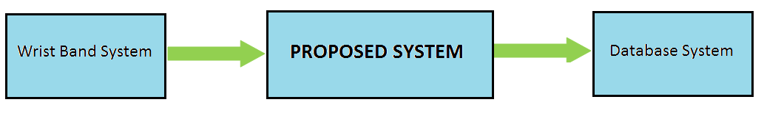
As we can see from the diagram, our proposed system is interacting with two other systems, namely Wrist Band system and Database System. The Wrist Band System sends data (received from the sensors) to the Proposed System. This data is received by the Proposed System in a specific predefined format. Then, the Proposed System (i-e Patient’s cell phone) sends this received data to the Database System in the form of a message (i-e. via SMS).

IDENTIFYING ACTORS

Actors of the system are the people or external systems interacting with the system in such a way that they give some input to the system or get some output from the system or both.

Actors of proposed system are as follows:

  - Wrist band System
  - Database System
  - Patient (user of the proposed system)

IDENTIFYING USE CASES AND PRECONDITIONS

- Use Case: Connection Request

Actor’s Goals:

Actors | Goals
Wrist Band System | Wants to make a connection with the proposed system (patient cell phone) to send data to the proposed system.
Database System | Wants to make a connection with the proposed system (patient cell phone) to receive data from the proposed system.

Actor’s Tasks to meet the goals:

Actors | Tasks to achieve goals
Wrist Band System | - Search for the cell phone  - Provide the specific ID of the wrist band
Database System | - Search for the cell phone  - Provide the specific ID of the database

Preconditions:

  - Both Database System and Wrist Band System are configured properly

- Use Case: Send Data

Actor’s Goals:

Actors | Goals
Wrist Band System | Send data to the proposed system (i-e patient’s cell phone)

Actor’s Tasks to meet the goals:

Actors | Tasks to achieve goals
Wrist Band System | - Select the data to be sent to the proposed system  - Send the selected data to the proposed system (cell phone)

Preconditions:

- Wrist Band System is configured properly
- Data has been gathered from the sensors already

- Use Case: Data conversion in message (to be sent to Database System)

Actor’s Goals:

Actors | Goals
Database System | Patient’s identification details (Name, ID etc…) and data received from the Wrist Band System should be converted in the form of a message

Actor’s Tasks to meet the goals:

Actors | Tasks to achieve goals
Database System | - Format the collected data in the message form  - Add patient’s identification details in the message

Preconditions:

- Data and patient details have been received by the cell phone from the wrist band properly

- Use Case: Receive Data

Actor’s Goals:

Actors | Goals
Database System | Data should be received by the Database System

Actor’s Tasks to meet the goals:

Actors | Tasks to achieve goals
Database System | - Select the message to be sent  - Send the message to the Database System

Preconditions:

- Data and patient details have been converted in the message form
- Database System and Proposed Systems are configured properly

- Use Case: Configure Wrist Band System

Actor’s Goals:

Actors | Goals
Patient | Configured the Wrist Band System properly

Actor’s Tasks to meet the goals:

Actors | Tasks to achieve goals
Patient | - Send the connection request to the Wrist Band System for the first time  - Enter the specific ID of the wrist band against its patient  - Confirm that connection is established

Assumption for the use case “Configure Wrist Band System”:

We are assuming that there is a specific ID of the wrist band which is provided to the customer at the time of purchase (or deployment) and that ID is used for the configuration purpose later. This ID is known only to the patient.

Preconditions:

- Patient have the ID of the wrist band

- Use Case: Configure Database System

Actor’s Goals:

Actors | Goals
Patient | Configured the Database System properly

Actor’s Tasks to meet the goals:

Actors | Tasks to achieve goals
Patient | - Send the connection request to the Database System for the first time  - Enter the specific ID for authentication provided by the hospital authorities to the patient  - Confirm that connection is established

Assumption for the use case “Configure Database System”:

We are assuming that for the first time configuration patient should visit the hospital to register himself in the Database System and there he should be provided with an ID that should be used for the configuration purpose later.
Preconditions:

- Patient had registered himself in the hospital database and have the ID

- Use Case: Login

Actor’s Goals:

Actors | Goals
Patient | Patient should be logged in to the proposed system properly

Actor’s Tasks to meet the goals:

Actors | Tasks to achieve goals
Patient | - Enter the user name  - Enter the password  - Get Logged in

Preconditions:

- User is registered with the Proposed System

DEFINITION OF PRIMARY AND SECONDARY SCENARIOS:

- Use Case: Connection Request

  - Brief description: This use case accepts the connection requests from the actors (Wrist Band System and Database System) and transfers them to the authentication use case to authenticate the Systems who have requested for the connection.

  - Flow of Events:
    - Basic flow:
      - Starts when Wrist Band System or Database System want to send or receive data respectively from/to the proposed system
      - It would first authenticate the system who had requested by calling to the authentication module
      - Once authenticated the System it would send a message of confirmation which would show that the connection is established
    - Alternate flow
      - If the system (who had requested for connection) is not an authorized system then it would show a message that unauthorized access is not allowed.

- Use Case: Send Data

- Brief description: This use case sends data (which was collected from the patient’s body using sensors) to the proposed system (cell phone of the patient).
- Flow of Events:
- Basic flow:
      - Starts when Wrist Band System wants to send data to the proposed system
      - Collected data is gathered together to be sent
      - Data is sent to the proposed system
- Alternate flow
      - If the proposed system (cell phone) is not available then data should not be sent and it should be stored for some time until the proposed system become available.

- Use Case: Data conversion in message

- Brief description: This use case would convert the data (which was received from the Wrist Band System) in the form of a message including the patient details also.

- Flow of Events:
- Basic flow:
      - Starts when data is to be sent to the Database System
      - Received data and patient details are gathered together
      - Both Data and patient details are converted into the form of a message

- Alternate flow
      - If the data is not received from the wrist band then the Proposed System should inform the Database System and should discard the conversion request

- Use Case: Receive Data
- Brief description: This use case would send the data (in the form of message) from the Proposed System to the Database System.

- Flow of Events:
- Basic flow:
      - Starts when data is to be sent to the Database System
      - Data which was converted in Message form is selected
      - Selected Message is sent to the Database System

- Alternate flow
      - If the data is not received properly to the Database System then the message should be sent again.

- Use Case: Configure Wrist Band System

- Brief description: This use case would configure the Wrist Band System using some ID with the Proposed System after first installation of the Proposed System.

- Flow of Events:
- Basic flow:
      - Starts when for the first time software (Proposed System) is installed on the cell phone and patient want to connect it with the wrist band
      - It would ask for the ID of the wrist band from the patient (which is provided to the patient at the time when he/she bought the wrist band)
      - It would authenticate that ID with the Wrist Band System
      - After authentication a notification would be shown to the patient that his/her wrist band has been configured properly

- Alternate flow
      - If the patient enters wrong ID then it would ask again for the correct ID

Exceptional flow
  - If the Wrist Band System’s ID crashes somehow then an exception (error message) should be raised accordingly.

- Use Case: Configure Database System

- Brief description: This use case would configure the Database System using some ID with the Proposed System after first installation of the Proposed System.

- Flow of Events:
- Basic flow:
      - Starts when for the first time software (Proposed System) is installed on the cell phone and patient want to connect it with the Database
      - It would ask for the ID from the patient (which is provided to the patient by the hospital authorities at the time when he/she Registered himself/herself at the hospital Database System)
      - It would authenticate that ID with the Database System
      - After authentication a notification would be shown to the patient that his/her cell phone (Proposed System) has been configured properly with the Database System

- Alternate flow
      - If the patient enters wrong ID, it would ask again for the correct ID.

Exceptional flow
  - If the Database System’s ID crashes somehow, an exception (error message) should be raised accordingly.

- Use Case: Login

- Brief description: This use case would enable the user/patient to log in by getting user name and password from the user/patient and authenticating him/her.

- Flow of Events:
- Basic flow:
      - Starts when the user/patient wants to sign in
      - It would ask for the username
      - It would ask for the password
      - After authentication a notification of successful sing in would be shown

- Alternate flow
      - If the patient enters the username/password wrong then it would ask again for the correct username/password

Exceptional flow
  - For unauthorized access an exception (error message) should be raised, indicating the unauthorized access.

USE CASE DIAGRAMS:
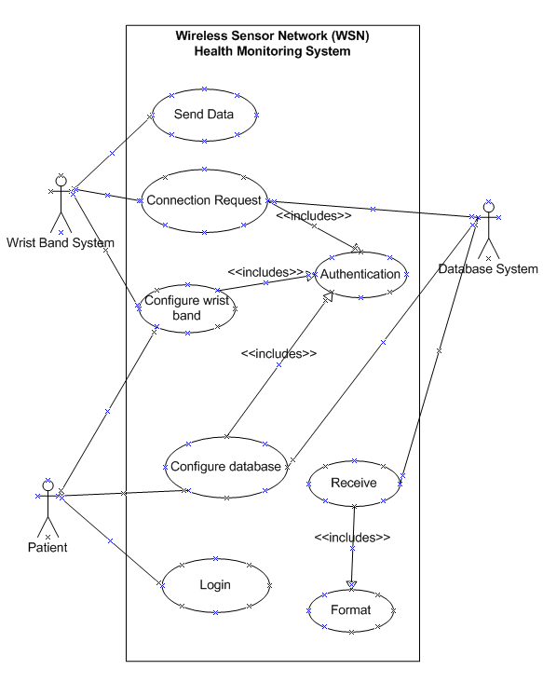
Figure 1: Complete Use Case Diagram of the Proposed System

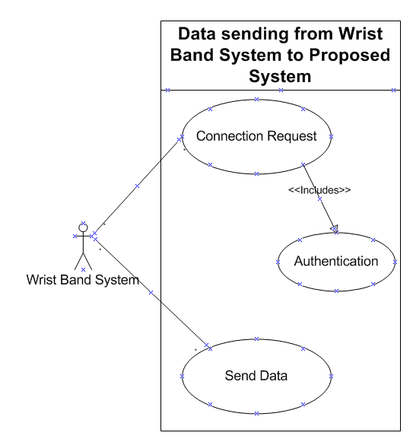
Figure 2: Data Sending from Wrist Band System to the Proposed System Use Case Diagram

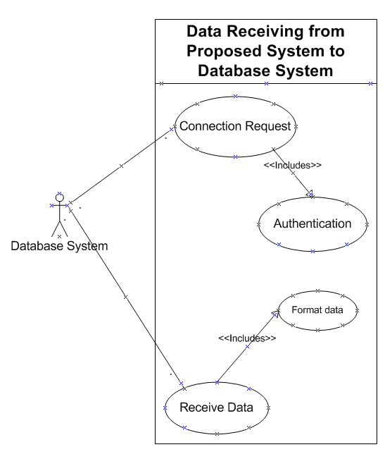s
Figure 3: Database System receiving data from the proposed system use case diagram

